#### Cardiologic examination report

|  |  |
| --- | --- |
| καρτα2 | **Date: {{ date }}**  **---**  **Mr./Ms. {{ owner }}**  **« {{ petName }} »**  {{ breed }}  {{ sex }}, {{weight }} kg  Ηλικία: {{age}} |

**Dr. Theodoros SINANIS**

DVM, MSc, MRCVS

*Master of Science in Veterinary Internal Medicine,*

*Specially trained in Veterinary Cardiology at the*

*Cardiology Unit of Alfort, Paris- France*

*(École Nationale Vétérinaire d'Alfort)*

*European Society of Veterinary Cardiology member*

** Medical history – clinical examination**

**History :**

* Referring physician:**{% if referVet %} {{referVet}}.{% else %} -{% endif %}**
* Cardiologic examination in account of previous murmur auscultation, during routine clinical examination. {% if historic %}{% for moment in historic %}
* {{ moment }}{% endfor %}
* {% endif %}Radiographic examination: {{radiologicalChestAnalysis}}
* Cardiac medication so far:{% if medication %}{% for med in medication %} **{{med.medicationEngMenu}}** ({{med.doseNumber}} {{med.unitOfMeasurementMenu}} {{med.doseMenu}}){% if not loop.last %},{% endif %} {% endfor %}{% else %} **None**{% endif %}**.**

**Clinical findings** : {% if rythm %}

* {{ rythm }}{% else %}{% endif %}{% if auditoryFindings %}Cardiac auscultation revealed a {{auditoryFindings.systolicEngMenu}}, {{auditoryFindings.degreeEngMenu}}, {{auditoryFindings.auscultationEngMenu}} murmur, with a PMI at the {{auditoryFindings.auditoryEngMenu}}, {{auditoryFindings.heartEngMenu}} at the {{auditoryFindings.valveEngMenu}}. {% else %}
* Cardiac auscultation revealed a systolic, 4th degree (4/6) regurgitant murmur, with a PMI at the left apex of the heart, at the mitral valve area.
* {% endif %}
* {{auditoryLung}}
* {{cough}}
* {{heartRate}}
* {% if mucous %}{% if mucous**==**’ND.’ %}Mucous membranes: {{mucous}} {% else %}{{mucous}}{% endif %}{% endif %}
* {% if dental %}{% if dental **==**’ND.’ %}Dental calculus: {{dental}}{% else %}{{dental}}{% endif %}{% endif %}
* {{bodyWeight}}.
* {{lymph}}

 **Echocardiography exam results**

The examination was performed with cardiac single crystal phased array probes (P 2-9 & P 1-5 mHz).

{% if PDF %}

|  |  |  |  |
| --- | --- | --- | --- |
| **Παράμετροι** |  | **Παράμετροι** |  |
| RVDd | {% if PDF.RVDd %}{{ PDF.RVDd }} {% else %}9.1 {% endif %}mm | Ao Vmax | Vmax = {% if PDF.AoVmax %}{{ PDF.AoVmax }} {% else %}1.55 {% endif %}m/s |
| IVSd | {% if PDF.IVSd %}{{ PDF.IVSd }} {% else %}10.4 {% endif %}mm | P Vmax | Vmax = {% if PDF.PVmax %}{{ PDF.PVmax }} {% else %}1.12 {% endif %}m/s |
| LVDd | {% if PDF.LVDd %}{{ PDF.LVDd }} {% else %}22.5 {% endif %}mm | Ant. mitral leaflet | 3.8 mm |
| PWd | {% if PDF.PWd %}{{ PDF.PWd }} {% else %}9.1 {% endif %}mm | Post. mitral leaflet | 2.1 mm |
| IVSs | {% if PDF.IVSs %}{{ PDF.IVSs }} {% else %}14.2 {% endif %}mm | Mitral E/A wave | {% if PDF.MitralE %}{{ PDF.MitralE }}{% else %}1.47{% endif %}/{% if PDF.Awave %}{{ PDF.Awave }} {% else %}1.11 {% endif %}({% if PDF.MVEA %}{{ PDF.MVEA }}{% else %}1.32{% endif %}) |
| LVDs | {% if PDF.LVDs %}{{ PDF.LVDs }} {% else %}12.6 {% endif %}mm | DT | {% if PDF.DT %}{{ PDF.DT }} {% else %}78 {% endif %}ms |
| PWs | {% if PDF.PWs %}{{ PDF.PWs }} {% else %}13.9 {% endif %}mm | RA/LA | 0,9 |
| FS | {% if PDF.FS %}{{ PDF.FS }} {% else %}36 {% endif %}% | Mit. reg. Vmax | {% if PDF.MRVmax %}{{ PDF.MRVmax }} {% else %}- {% endif %}m/s |
| LA- Ao | {% if PDF.LA %}{{ PDF.LA }}{% else %}33.7{% endif %}-{% if PDF.Ao %}{{ PDF.Ao }} {% else %}18.1 {% endif %}mm | Tric. reg. Vmax | {% if PDF.TRVmax %}{{ PDF.TRVmax }} {% else %}- {% endif %}m/s |
| LA/Ao | {% if PDF.LAAo %}{{ PDF.LAAo }}{% else %}1.87{% endif %} | PT/Ao | 1 |

{% else %}

|  |  |  |  |
| --- | --- | --- | --- |
| **Parameters** |  | **Parameters** |  |
| RVDd | 9.1 mm | Ao Vmax | Vmax = 1.55 m/s |
| IVSd | 10.4 mm | P Vmax | Vmax = 1.12 m/s |
| LVDd | 35.3 mm | Ant. mitral leaflet | 3.8 mm |
| PWd | 9.1 mm | Post. mitral leaflet | 2.1 mm |
| IVSs | 14.2 mm | Mitral E/A wave | 1.47/1.11 (1.32) |
| LVDs | 22.5 mm | DT | 78 ms |
| PWs | 13.9 mm | RA/LA | 0.9 |
| FS | 36 % | Mit. reg. Vmax | - m/s |
| LA- Ao | 33.7-18.1 mm | Tric. reg. Vmax | - m/s |
| LA/Ao | 1.87 | PT/Ao | 1 |

{% endif %}

## Interpretation

Περιγραφή: Περιγραφή: ac387 **Right parasternal and transventricular short-axis view (m-mode):**

* Normal end-diastolic LV dimensions & normal end-systolic dimensions.
* The contractility of the LV is WNL.
* Normal right ventricular dimensions.

Περιγραφή: Περιγραφή: ac387 **Left atrium examination presents:**

* The left atrial dimensions are increased at the end-systole.
* Significant regurgitant volume (~265mm2; 6.9ml) through the mitral valve to the left atrium is present on colour flow Doppler examination.

Περιγραφή: ac387 **Right parasternal and transaortic short-axis view:**

* No anatomic lesions were found at the level of the pulmonary annulus.
* Normal pulmonic flow.
* No pulmonic regurgitation is present.

Περιγραφή: ac387 **Right parasternal long-axis four & five chamber views:**

* Mitral valve (anterior leaflet) shows severe thickening and moderate prolapse, compatible with degenerative lessions.
* Normal right atrial dimensions.
* Normal right to left atrial ratio.
* No aortic regurgitation is present.
* No interventricular nor interatrial septal defect was found.

Περιγραφή: ac387 **Left parasternal long-axis four & five chamber views:**

* Luminar aortic flow at the level of the aortic annulus.
* {% if flow %}{{ flow |e}}{% else %}Normal transmitral flow velocity.{% endif %}
* Tricuspid regurgitation is present on colour-flow Doppler.

Περιγραφή: Περιγραφή: ac387 **Other points:**

* No pericardial nor pleural effusion is present.
* Mild pulmonary hypertension is present (**36**mmHg).
* Sinus rhythm (**sinus arrhythmia**) during the examination. Heart rate: 92 bpm.

### Conclusions

* **Degenerative mitral valve disease** of 2nd echocardiographic stage (**2/5**); **{{clinicalStage}}** clinical stage (*ACVIM Consensus 2019*), {{hypertension}}{% if PG %} (PG: {{PG}} mmHg){% else %}{% endif %}{% if AddOn %} and {{AddOn}}{% else %}{% endif %}.
* Mitral valve disease (endocardiosis) appears frequently in aged, small sized dogs and is characterised by degeneration of one or both mitral leaflets, with or without valve prolapse.
* The prognosis is usually favorable, especially in early stages and it is characterized by good quality of life.
* A 2nd echocardiographic examination is recommended after {% if checkUp %}{% for che, months, years in checkUp %}{{che}} months (**{{months}} {{years}}**){% endfor %}{% else %}8-12 months(**March - July 2021**){% endif %}.

{% if medication2 %}

* Cardiac medication: {% for med2 in medication2 %}

1. **{{med2.medication2EngMenu}}** ({{med2.doseNumber}} {{med2.unitOfMeasurementMenu}} {{med2.doseMenu}}) {% endfor %}{% else%}

* Cardiac medication: **not recommended.**

{% endif %}

**Yours sincerely:**

**Dr. Theodoros Sinanis**

**Δρ. Θεόδωρος Σινάνης**

[theodsin@hotmail.com](mailto:theodsin@hotmail.com)

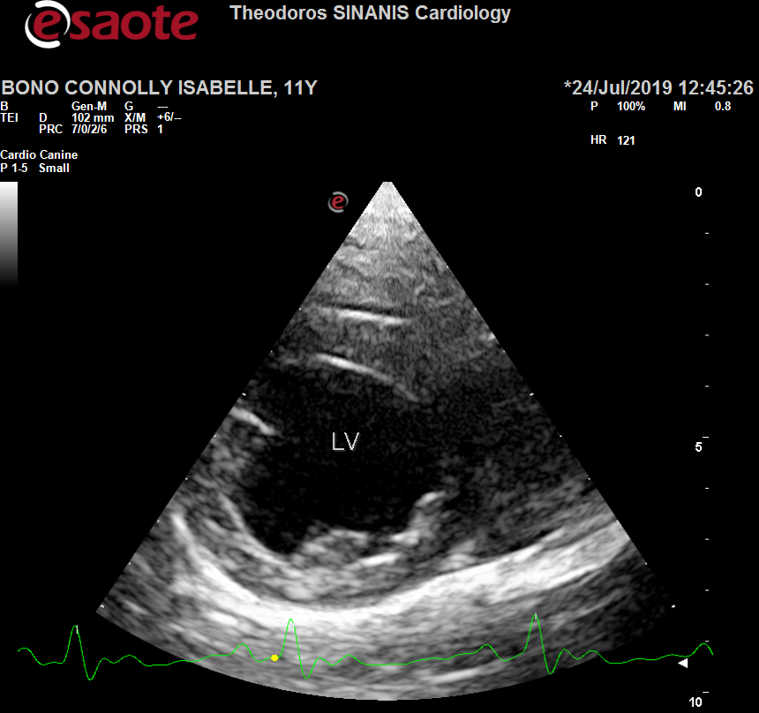 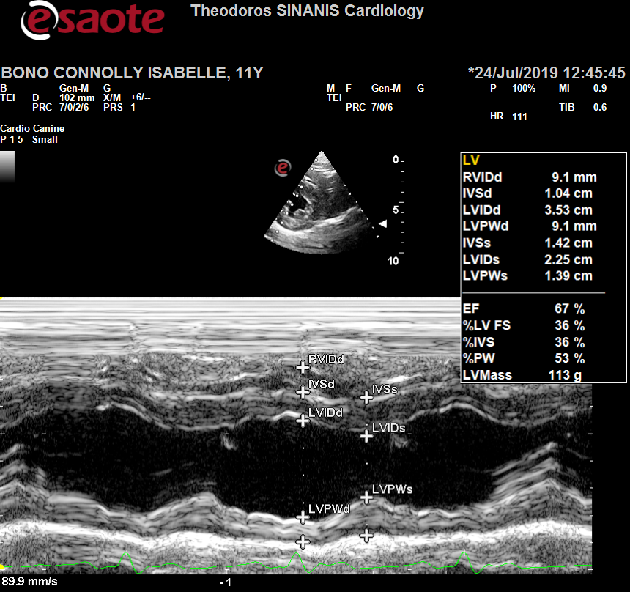

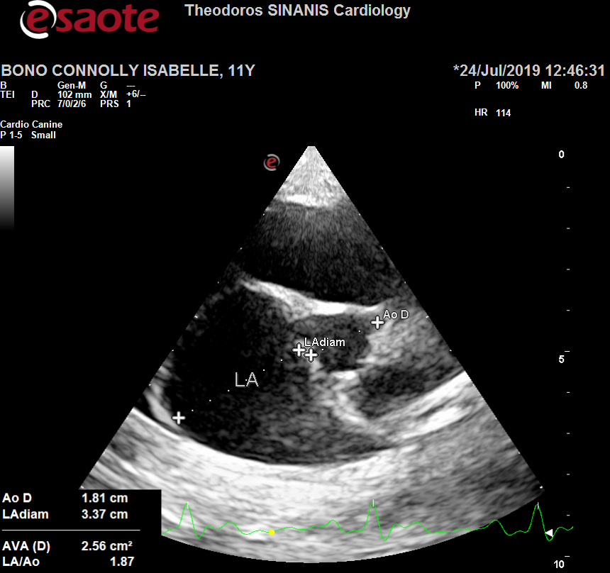 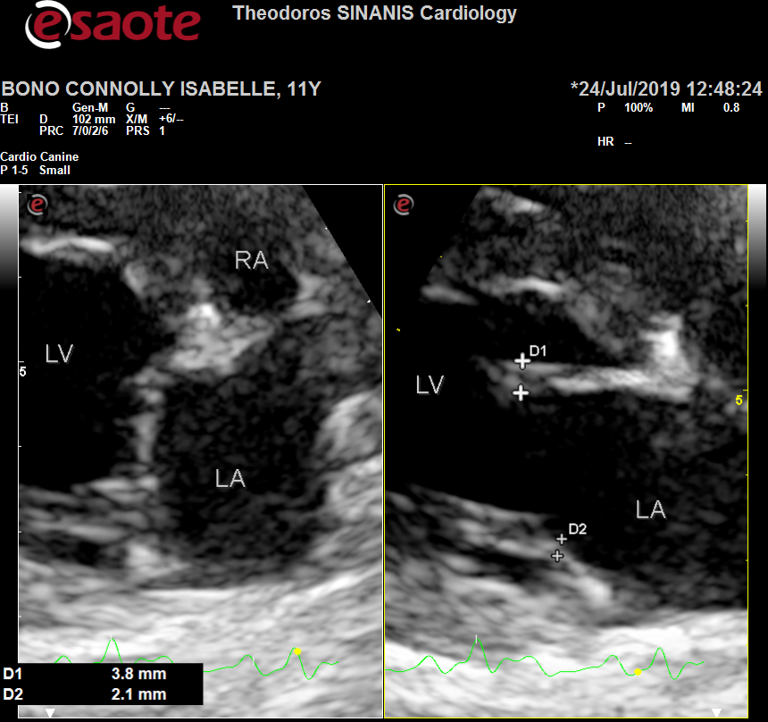

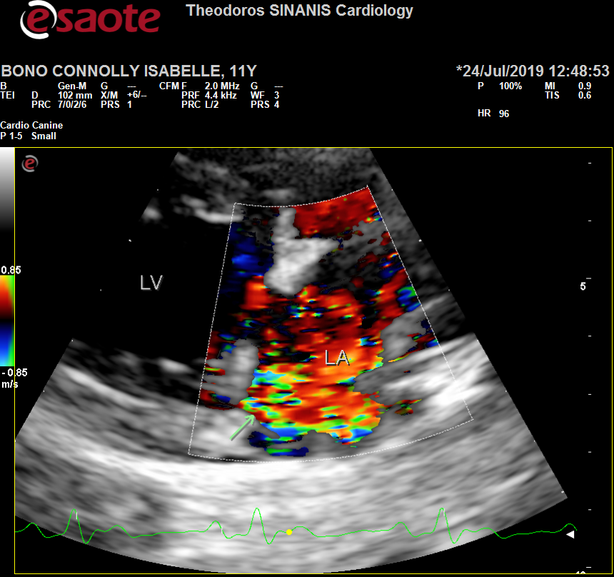 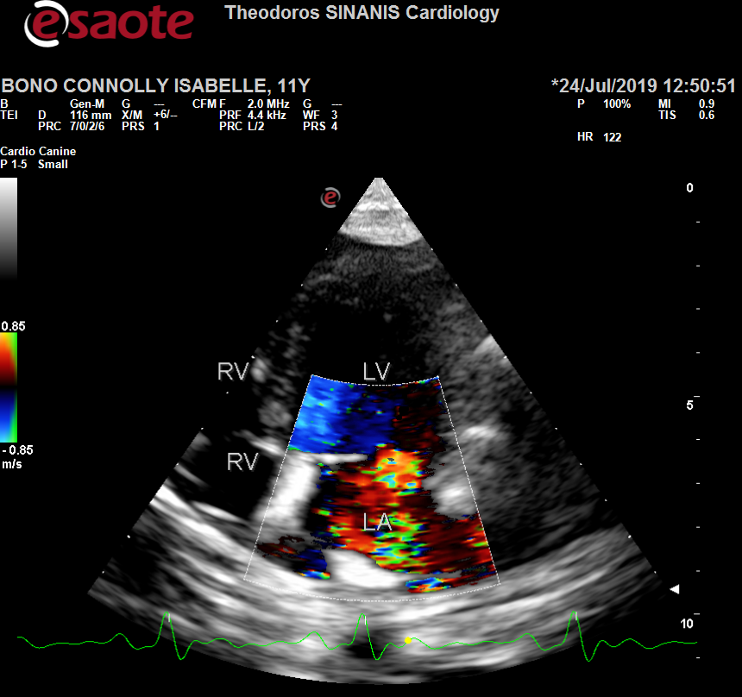

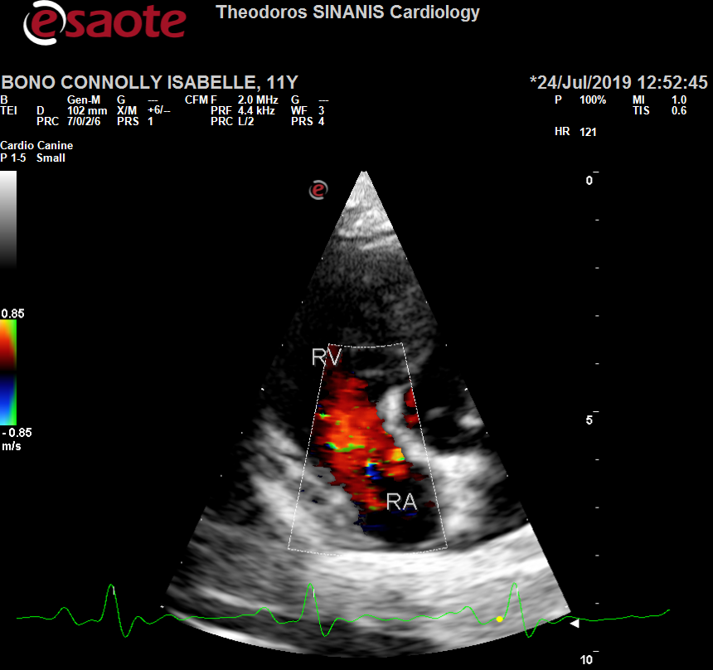 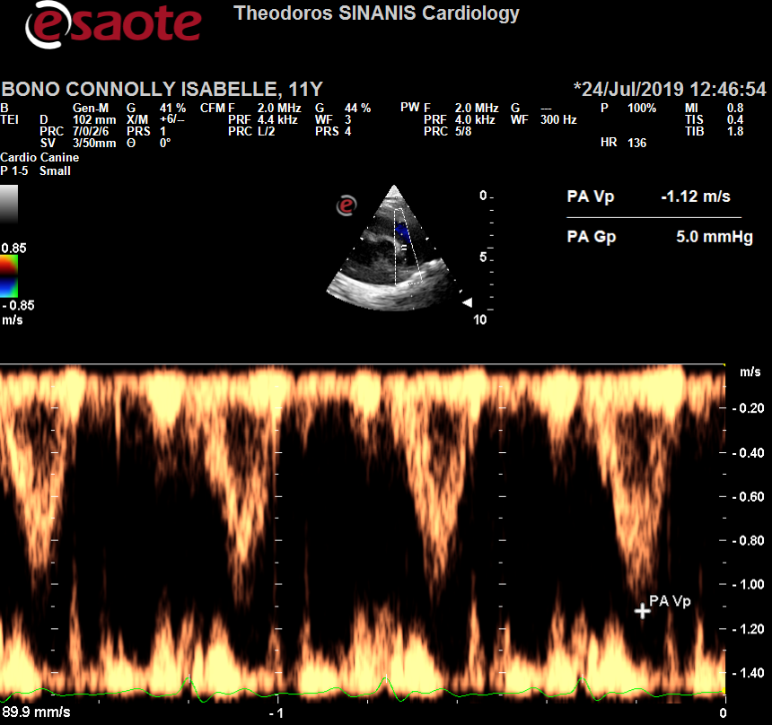

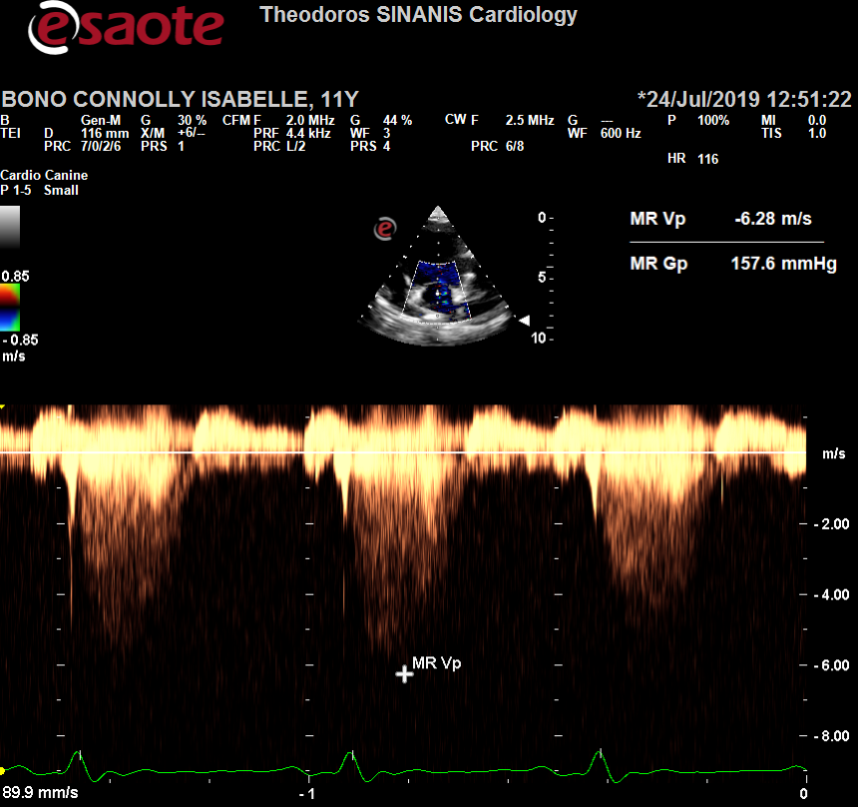 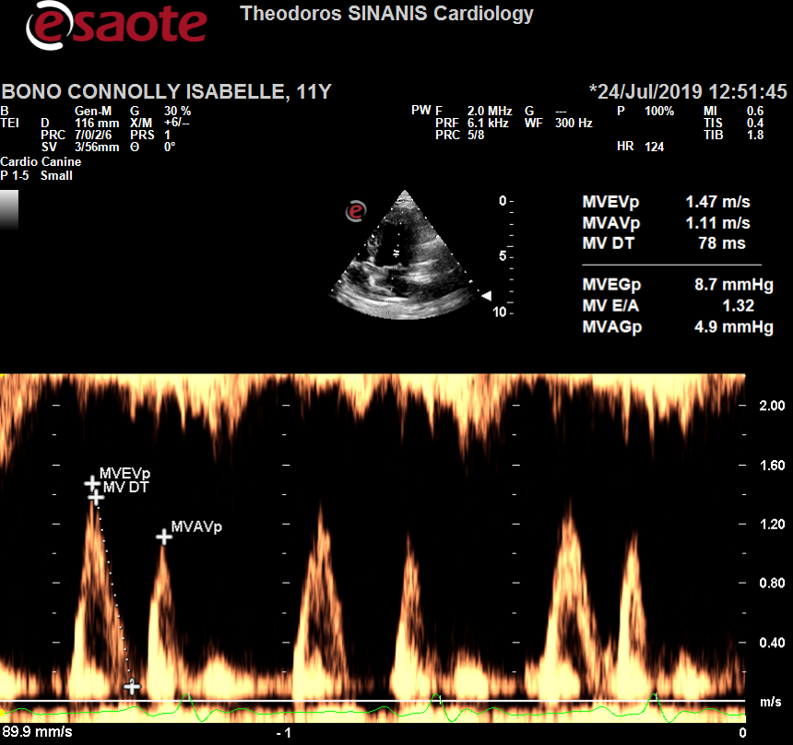

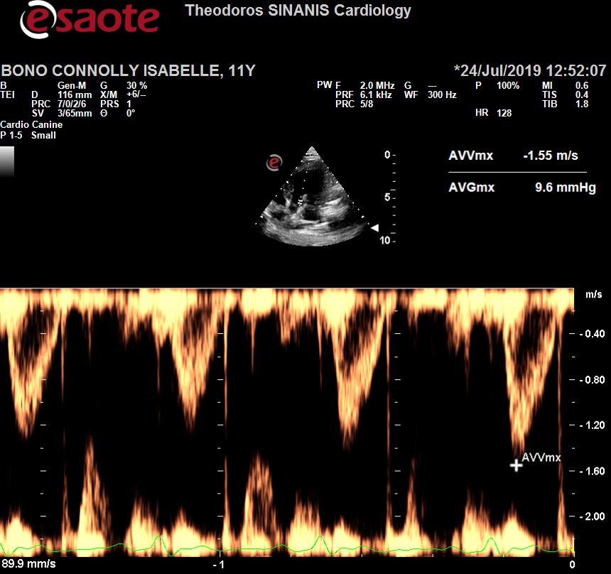 Description: Περιγραφή: Περιγραφή: ac387Περιγραφή: Περιγραφή: ac387Περιγραφή: Περιγραφή: ac387